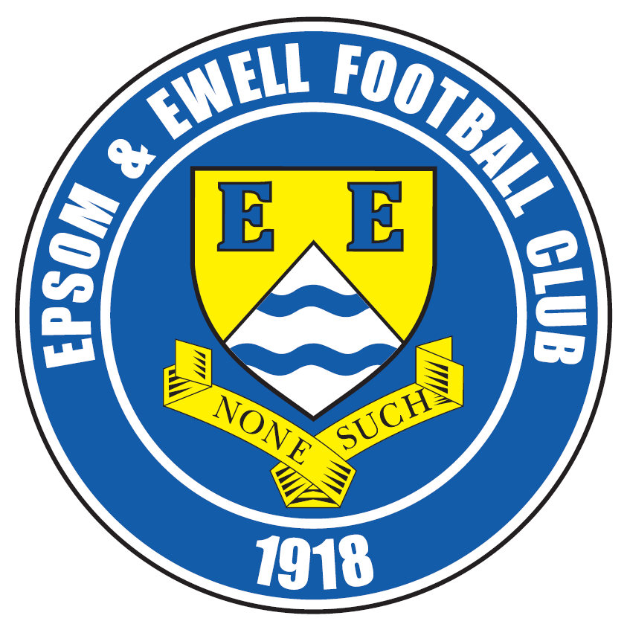 | Epsom & Ewell F.C.  10  v  Dorking Wanderers  Tuesday, 20th October 2015
Good evening! We welcome the players, supporters and officials of Dorking Wanderers for this Surrey Senior Cup match, together with today’s match officials and of course our regular faces.

We have never met our opponents competitively before, although have had a couple of friendlies against them previously. The first time was back on 17th July 2010 when both our First team and Reserves travelled to their picturesque home in Westhumble on a warm, sunny day, winning the first team match 2-0 and drawing the Reserve match 1-1.

We also met in the Dave Wilson Trophy when it was hosted at Colliers Wood United’s Wibbandune ground. Both sides lost their first match in the tournament, so we met in the Third place play off on 27th July 2013 and prevailed 3-1 on penalties after a goalless draw.

Since then it is fair to say our opponents have improved substantially and currently look very comfortable in their new Ryman League surroundings. Their geographical surroundings are also due to change shortly once the old Dorking ground at Meadowbank is refurbished as they are to share with their neighbours; an issue that has been contested quite a bit frequently in the local papers! The opportunities to progress at a new multi-million pound venue are exciting, and they may even emulate Dorking in the near future by reaching the Premier Division of the Isthmian League.

We were last here three days ago when we hosted Chertsey Town, and lost our unbeaten league record with a narrow single goal defeat. To be fair it was probably the correct result over the ninety minutes as we created very little and the service to Kyle and Thomas up front was very limited. We have to bounce back tonight and on Saturday.

Following today’s match we travel to Ashford Town on Saturday for an important League fixture. We then have a Saturday off due to Bedfont Sports having an F.A. Vase match and so we should be fully refreshed for our next contest which is back here on Saturday 7th November when Chessington & Hook United visit for a League fixture.

The winners of this tie will travel to play the holders, Met Police on Tuesday 1st December and all that remains to be said is that the new rule in this competition means that this match would be decided on penalties if the scores are level after 90 minutes.

Enjoy the game!

Rich

Why not follow us on Facebook www.facebook.com/epsomandewellfc or Twitter @EEFCOfficial

Programme Cover Photos by Gemma Jarman

- Michael Eacott saves the first Banstead penalty in last Tuesday’s shootout
- Alex McGregor puts us ahead in that match


Cherry Red Records Combined Counties League
Premier Division Table 2015/16
inc Saturday 17th October | P | W | D | L | F | A | Pts | GD | H | A
Ashford Town (Mx) | 14 | 11 | 0 | 3 | 31 | 16 | 33 | +15 | 30/4 | 24/10
Camberley Town | 13 | 9 | 3 | 1 | 21 | 10 | 30 | +10 | 16/4 | 20/2
Horley Town | 12 | 8 | 1 | 3 | 32 | 13 | 25 | +19 | 27/2 | 28/12
Hartley Wintney | 8 | 8 | 0 | 0 | 33 | 6 | 24 | +27 | 30/1 | 17/11
Epsom & Ewell | 11 | 7 | 3 | 1 | 26 | 9 | 24 | +17 | X | X
Hanworth Villa | 11 | 7 | 1 | 3 | 20 | 11 | 22 | +9 | 21/11 | 23/4
Knaphill | 12 | 6 | 1 | 5 | 22 | 14 | 19 | +8 | 12/3 | 14/11
Raynes Park Vale | 12 | 6 | 0 | 6 | 29 | 26 | 18 | +3 | 3-1 | 28/3
Chessington & Hook | 12 | 5 | 2 | 5 | 22 | 20 | 17 | +2 | 7/11 | 19/3
Spelthorne Sports | 13 | 5 | 2 | 6 | 23 | 27 | 17 | -14 | 16/1 | 6-2
Colliers Wood United | 13 | 5 | 1 | 7 | 26 | 22 | 16 | +4 | 3-1 | 28/11
Westfield | 11 | 4 | 4 | 3 | 15 | 14 | 16 | +1 | 26/3 | 0-0
AFC Hayes | 12 | 5 | 1 | 6 | 14 | 15 | 16 | -1 | 1-1 | 9/1
Guildford City | 13 | 5 | 1 | 7 | 22 | 34 | 16 | -12 | 5/12 | 2/4
Windsor | 12 | 3 | 6 | 3 | 16 | 23 | 15 | -7 | 2-2 | 23/1
Farnham Town | 10 | 4 | 1 | 5 | 19 | 13 | 13 | +6 | 1-0 | 6/2
Sutton Common Rovers | 12 | 3 | 1 | 8 | 21 | 32 | 10 | -11 | 19/12 | 2-1
Badshot Lea | 12 | 3 | 1 | 8 | 17 | 37 | 10 | -20 | 9/4 | 12/12
Chertsey Town | 12 | 2 | 3 | 7 | 9 | 19 | 9 | -10 | 0-1 | 5/3
Redhill | 12 | 2 | 2 | 8 | 18 | 30 | 8 | -12 | 2/1 | 1-0
Bedfont Sports | 9 | 1 | 4 | 4 | 11 | 13 | 7 | -2 | 13/2 | 24/11
Cove | 12 | 1 | 0 | 11 | 6 | 48 | 3 | -42 | 8/12 | 7-0

Lucky Day? – 20th October
Played 14 - W 7 D 3 L 4 - F 28 A 18 - PPG 1.71 - Good
Our Club record against Dorking Wanderers
The two clubs have never met competitively
Did You Know?
We have now had six competitive penalty shootouts in our history, winning two but losing four.

Our first was way back on Tuesday 16th August 1983 when we drew 1-1 after extra time with Walton & Hersham in the held over Southern Combination Cup Final, but lost 5-4. Further defeats followed against Molesey (0-3), Egham Town (14-15) and more recently Spelthorne sports (2-4) but we did defeat Worcester Park 5-4 in a League Cup tie at Moatside, Merstham on Tuesday 5th October 2010.

First Eleven Appearances - (max 14 – including Chertsey Town – 17/10/15)
Name | Debut | 2014/15 |  |  |  | Career Totals
Name | Debut | App | Sub | Total | Goals | App | Sub | Total | Goals
AJAYI Tayo | 22/08/2015 | 0 | 2 | 2 | 0 | 0 | 2 | 2 | 0
COOPER-SMITH Daryl | 03/01/2015 | 8 | 4 | 12 | 4 | 17 | 7 | 24 | 10
CURRIE Sam | 04/08/2012 | 12 | 1 | 13 | 0 | 120 | 10 | 130 | 2
DAVISON Conor | 22/08/2015 | 1 | 2 | 3 | 0 | 1 | 2 | 3 | 0
DEAN Dan | 02/08/2014 | 14 | 0 | 14 | 0 | 50 | 1 | 51 | 0
DEWAR Ali | 29/10/2011 | 0 | 0 | 0 | 0 | 55 | 35 | 90 | 10
EACOTT Michael | 02/08/2014 | 12 | 0 | 12 | 0 | 58 | 0 | 58 | 0
FARRELL Matt | 02/08/2014 | 13 | 0 | 13 | 3 | 54 | 3 | 57 | 10
FERDINANDO Matt | 20/09/2014 | 8 | 0 | 8 | 1 | 35 | 4 | 39 | 7
GRIFFIN Reisse | 08/08/2015 | 5 | 0 | 5 | 0 | 5 | 0 | 5 | 0
HASTINGS Craig | 08/08/2015 | 7 | 3 | 10 | 0 | 7 | 3 | 10 | 0
HENDRY Rob | 08/08/2015 | 12 | 1 | 13 | 5 | 12 | 1 | 13 | 5
HOUGH Kyle | 14/08/2007 | 12 | 0 | 12 | 10 | 308 | 15 | 323 | 181
JONES Adrian | 06/08/2011 | 1 | 0 | 1 | 0 | 21 | 0 | 21 | 0
KURDZIEL Jakub | 29/08/2015 | 1 | 0 | 1 | 0 | 1 | 0 | 1 | 0
MARVELL Dale | 15/01/2000 | 7 | 4 | 11 | 1 | 268 | 49 | 317 | 86
MCGREGOR Alex | 08/08/2009 | 6 | 2 | 8 | 2 | 178 | 58 | 236 | 29
MCKAY Alex | 20/12/2008 | 7 | 1 | 8 | 0 | 92 | 27 | 119 | 8
NEALE Thomas | 13/10/2015 | 1 | 1 | 2 | 0 | 1 | 1 | 2 | 0
NEILL David | 03/10/2015 | 1 | 1 | 2 | 0 | 1 | 1 | 2 | 0
NORTH Rhys | 16/08/2015 | 1 | 6 | 7 | 0 | 1 | 6 | 7 | 0
OLIVER Beckett | 29/08/2015 | 2 | 4 | 6 | 0 | 2 | 4 | 6 | 0
PANAYIOTOU Savvas | 03/01/2015 | 2 | 0 | 2 | 0 | 18 | 3 | 21 | 3
SMITH Matt | 08/08/2009 | 0 | 0 | 0 | 0 | 91 | 43 | 134 | 10
TANTON Matt | 02/08/2014 | 11 | 0 | 11 | 0 | 29 | 4 | 33 | 1
TAYLOR James | 26/08/2013 | 9 | 2 | 11 | 0 | 65 | 10 | 75 | 3
Own Goal |  |  |  |  |  |  |  |  | 1

Latest Results and Fixtures
Combined Counties League – Saturday 17th October
Badshot Lea | 2-1 | AFC Hayes
Bedfont Sports | 0-1 | Ashford Town (Mx)
Chessington & Hook United | 0-2 | Knaphill
Cove | 0-5 | Redhill
Epsom & Ewell | 0-1 | Chertsey Town
Guildford City | 2-4 | Spelthorne Sports
Hanworth Villa | 0-2 | Camberley Town
Horley Town | 2-1 | Colliers Wood United
Raynes Park Vale | 1-2 | Hartley Wintney
Sutton Common Rovers | 0-3 | Farnham Town
Windsor | 0-1 | Westfield
Surrey Senior Cup 2nd Round – Tuesday 20th October
Camberley Town | V | Knaphill
Epsom & Ewell | V | Dorking Wanderers
Combined Counties League – Tuesday 20th October
Chessington & Hook United | V | Colliers Wood United
Raynes Park Vale | V | Farnham Town
Combined Counties League – Friday 23rd October
Hanworth Villa | V | Redhill
Combined Counties League – Saturday 24th October
AFC Hayes | V | Cove
Ashford Town (Mx) | V | Epsom & Ewell
Camberley Town | V | Sutton Common Rovers
Chertsey Town | V | Bedfont Sports
Chessington & Hook United | V | Guildford City
Colliers Wood United | V | Badshot Lea
Farnham Town | V | Windsor
Knaphill | V | Hartley Wintney
Spelthorne Sports | V | Horley Town
Westfield | V | Raynes Park Vale
Surrey Senior Cup 2nd Round – Tuesday 27th October
Ashford Town (Mx) | V | Beckenham Town
Combined Counties League – Tuesday 27th October
AFC Hayes | V | Hartley Wintney
Chertsey Town | V | Raynes Park Vale
Chessington & Hook United | V | Bedfont Sports
Latest Results and Fixtures
Combined Counties League – Tuesday 27th October
Horley Town | V | Guildford City
Combined Counties League – Wednesday 28th October
Colliers Wood United | V | Hanworth Villa
F.A. Vase First Round – Saturday 31st October
Bedfont Sports | V | Carterton
Bowers & Pitsea | V | Hanworth Villa
Cove | V | Canterbury City
Eastbourne Town | V | Farnham Town
Hartley Wintney | V | Wokingham & Emmbrook
Kidlington | V | Ashford Town (Mx)
Knaphill | V | Cray Valley (PM)
Lancing | V | Camberley Town
Windsor | V | Croydon
Worthing United | V | Sutton Common Rovers
Combined Counties League – Saturday 31st October
Badshot Lea | V | Spelthorne Sports
Raynes Park Vale | V | AFC Hayes
Westfield | V | Colliers Wood United
Combined Counties League – Tuesday 3rd November
Bedfont Sports | V | Farnham Town
Hartley Wintney | V | Spelthorne Sports
Knaphill | V | Ashford Town (Mx)
Combined Counties League – Saturday 7th November
Bedfont Sports | V | Guildford City
Chertsey Town | V | Sutton Common Rovers
Colliers Wood United | V | AFC Hayes
Cove | V | Camberley Town
Epsom & Ewell | V | Chessington & Hook United
Farnham Town | V | Ashford Town (Mx)
Hanworth Villa | V | Hartley Wintney
Horley Town | V | Westfield
Knaphill | V | Badshot Lea
Raynes Park Vale | V | Windsor
Redhill | V | Spelthorne Sports
Combined Counties League – Tuesday 10th November
Bedfont Sports | V | Hartley Wintney
Redhill | V | Farnham Town
Windsor | V | Chessington & Hook United

Match Report by Sam Brooker
Epsom & Ewell 0-1 Chertsey Town
Combined Counties League Premier Division - Saturday 17th October 2015

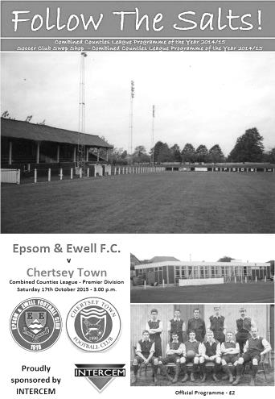
Salts restricted by visiting Curfews

On Saturday 17th October we witnessed Chertsey Town visit Epsom and Ewell at home. A hotly anticipated encounter, particularly by Thomas Neale and Conor Davison, both of whom were making their debuts in the starting line-up. In addition - and to the detriment of the team - Captain Currie was excluded from the squad due to an injury, resultant of a horrific tackle in Tuesday’s match against Banstead. Rob Hendry and Ferdinando (the hero of the 1-0 victory over Farnham) were both unavailable for this fixture.

Despite the home side’s superior position in the league, Chertsey began the game brimming with confidence, executing some intricate displays of passing and trickery (particularly from Chertsey’s Kieron Woodley) in order to neatly slice through Epsom’s half. However, a combination of Matt Tanton’s resolute defending, aided by the booming, unrelenting instructions being spouted from Michael Eacott and the centre backs, forced the visitors to resort to long balls which were far easier to deal with. Overall, it was a fairly even initiation to the fixture, with many of the early set pieces being awarded in favour of the home side. Epsom then - disappointingly - delivered speculative long crosses that neither excited the 47 people in attendance nor worried the opposition.

The initial stages resembled a strategic game of Chess… only with greater physicality! Chertsey’s Tommy Batten had his work cut out for him as the responsibility of dealing with Kyle Hough’s sniping runs, these intelligent runs were in vain as Epsom were impossibly disjointed in the final third. Eventually, as if the players were taking heed of the vociferous crowd, our boys began playing the ball along the floor and injecting some pace into the match, thus creating the first promising chance, which was desperately smothered by Chertsey. Alex McKay, accompanied by some of his midfield colleagues, did a sterling job at intercepting any stray passes in order to create countering opportunities, although the strike force often found themselves lonesome whenever an opportunity did arise. The defence were impeccable in the air, especially Tanton, winning aerial balls against opposition of augmented stature on several occasions at left back.

Chertsey came the closest to finding the back of the net with a header in the 16th minute that ricocheted off of the crossbar, following some tremendous build up play on the left, the speed of which left Eacott rooted to the spot as the attempt contacted the woodwork. The 17th minute then saw the first of many aggressive challenges on Matt Farrell, as a consequence of his intensity and ability to conjure up a scoring opportunity at any given moment.

The lacklustre passing midway through the half maimed Epsom and Ewell’s attacking prowess and halted almost all momentum that had been gathered. Matt Farrell was the linchpin of The Salts’ attacks with his direct running and neat passes, unfortunately, the passes were too often not

returned to his continued run in behind the defence. The home side were regularly unleashing shots from ambitious distances and just as regularly, were sending them well over the crossbar - to the frustration of the supporters. The deputising captain (Dan Dean) and Craig Hastings assumed responsibility of exerting a calming presence by keeping the ball between them and forming a foundation in Epsom’s own half before launching any form of attack, this composure then filtered through the ranks as the performance of our boys dramatically improved.

Unfortunately, this was short lived as in the 29th minute; Tanton (in accordance with his fellow defenders recklessly committing to unnecessary challenges) mistimed a tackle on the edge of our box, providing Chertsey with an opportune moment to take the lead. A special mention must go to Eacott for his athletic save to his left, keeping the scores level as half time approached. Following this, a sliced shot from Chertsey provided an apt summary of the goalless first half, which left much to be desired from both sides. Epsom then dominated possession and were camped in opposition territory for the majority of the time remaining in the first period.

The visitors demonstrated their intentions early on in the second half with some superb shots that posed real threats to the 0-0 score line. Eventually, the home side rumbled into life and managed to retain possession long enough to earn a corner for their efforts but nothing more. Some boisterous play from Tommy Batten on Hough resulted in Farrell taking a quick free kick in the 53rd minute, which was called back by the referee, who seemed determined to maintain a slow pace to the game. To the delight of the fans, the Blues found themselves queuing up to steer a promising cross in open play into the goal.

However, rather predictably, Epsom were unable to capitalise as Thomas Neale was unable to produce sufficient power in order to cause the keeper George Armstrong a problem. The Salts lackadaisical pressing of the ball allowed Chertsey plenty of time to regroup and distribute the ball safely following any Epsom possession. In the 62nd minute, Hough flew down the left wing, laid the ball back inside for Farrell to strike first time but the effort unfortunately zipped past the right hand goalpost. Epsom’s frustrations were manifested by the bookings of Tanton in the 64th minute and Farrell in the 69th minute, both due to overly enthusiastic challenges. We then made a substitution in the 66th minute, bringing on Daryl Cooper-Smith for Neale. Soon after, in the 74th minute, Farrell hacked at the quick feet of Chertsey’s star man Andy Crossley and a free kick was given on the perimeter of the box. Crossley punished Epsom with an untouchable set piece that nestled into the top right corner, putting Chertsey 1-0 up.

Conor Davison was taken off for Beckett Oliver in the 75th minute and Dan Dean (Captain), was removed in the 82nd minute for Rhys North. Last gasp crosses from Epsom began steaming over the bar as anxiety increased amongst the players, allowing Chertsey plenty of opportunities to expend more of the - now limited - time. The away team pressed the ball excellently, forcing Epsom to play narrowly and Chertsey merely ran the clock down until the final whistle. Credit should go to our boys for sticking to the task and winning two free kicks in injury time, however, both were wasted in similar fashions - being dispatched over the crossbar. The match finished 1-0 to Chertsey, leaving Epsom with little to complain about bar an inferior performance on the day.

Team: Michael Eacott, James Taylor, Matt Tanton, Dan Dean ©, Craig Hastings, Alex McKay, Dale Marvell, Matt Farrell, Kyle Hough, Thomas Neale, Conor Davison

Subs: Daryl Cooper-Smith for Neale (66), Beckett Oliver for Davison (75),
Rhys North for Dean (82)

Club Records - 20th October
Date | Day | Competition |  | Opponents |  | Scorers
20/10/28 | Sat | Amateur Cup 2q | A | Sutton United | 2-3 | J.Parr, R.Marlow
20/10/34 | Sat | Amateur Cup 2q | H | Tooting & Mitcham United | 3-0 | E.Hannam, M.Wiggins, T.Dunne
20/10/45 | Sat | Friendly | H | Catford Wanderers | 3-1 | R.Buller, J.Jones, T.Rochester
20/10/51 | Sat | Corinthian Memorial Shld 2 | H | Eastbourne | 3-3 | B.Goddard, J.Hoy, R.Orford
20/10/56 | Sat | Corinthian League | A | Maidenhead United | 3-5 | R.Colfar, J.Bangs, D.Hermitage
20/10/62 | Sat | Surrey Senior Cup 2q | A | Worcester Park | 4-0 | E.Arnall (2), D.Prowse (pen), R.Jones
20/10/73 | Sat | Surrey Senior Cup 2q | H | Kew Association | 1-2 | T.Tuite (pen)
20/10/79 | Sat | London Senior Cup 1q | A | Beckenham Town | 2-0 | R.Lewis, D.Walker
20/10/84 | Sat | F.A. Trophy 1q | A | Andover | 0-0
20/10/87 | Tue | Isthmian League 2s | H | Whyteleafe | 2-2 | J.Richardson (2)
20/10/90 | Sat | Isthmian League 2s | A | Banstead Athletic | 2-0 | T.Tweedy, A.Boxall
20/10/07 | Sat | Combined Counties  Premier Division | H | Guildford City | 1-0 | D.Smith
20/10/09 | Tue | Combined Counties  League Cup 2 | A | North Greenford United | 0-1
20/10/12 | Sat | Combined Counties  Premier Division | H | Hanworth Villa | 2-1 | K.Hough (2)
Historical Decades
Date | Day | Competition |  | Opponents |  | Scorers
90 years ago – Epsom Town F.C.
24/10/25 | Sat | Surrey Senior League | A | Egham | 3-1 | T.Evans (2), R.Sperring
80 years ago – Epsom F.C.
19/10/35 | Sat | London League Cup 2 | A | Tilbury | 1-4 | J.Jones (pen)
70 years ago – Epsom F.C.
20/10/45 | Sat | Friendly | H | Catford Wanderers | 3-1 | R.Buller, J.Jones, T.Rochester
60 years ago – Epsom F.C.
22/10/55 | Sat | F.A. Cup 3q | H | Margate | 1-3 | R.Colfar
50 years ago – Epsom & Ewell F.C.
23/10/65 | Sat | Amateur Cup 2q | A | Chobham | 3-1 | T.Wiltshire (2), P.Deadman
40 years ago – Epsom & Ewell F.C.
21/10/75 | Tue | Southern Combination Cup 1 | A | Aldershot Services | 0-1
30 years ago – Epsom & Ewell F.C.
19/10/85 | Sat | Isthmian League  Premier Division | A | Billericay Town | 0-0
20 years ago – Epsom & Ewell F.C.
21/10/95 | Sat | Isthmian League 3 | H | Clapton | 2-1 | P.Meredith, A.Boxall
10 years ago – Epsom & Ewell F.C.
22/10/05 | Sat | Isthmian League 2 | A | Kingsbury Town | 0-1

History Corner – 20th October
77 years ago today we were defeated in the Amateur Cup 3-2 by Sutton United. This match started a chain of events that neither team benefitted from, as Epsom protested after the match that two opposition players, Okin and White also played Sunday football. Back then, Sunday footballers were essentially not recognised by the F.A. and were therefore ineligible in their eyes.

However, rumours persisted that our club had known about the players and were intending to protest, even before the result was known. The press were quite harsh on our Secretary Billy Green, describing our appeal as “tenuous” and although he defended himself, advising that he only knew about the players at half time in the match, it left a sour taste between the clubs.

However, what was really strange was that despite the circumstances, everyone seemed to accept that these players were ineligible, except the F.A. who surprisingly came down on Sutton’s side and fined Epsom the two guineas cost of the appeal!

Sutton progressed in the Amateur Cup but the cat was out of the bag and in February Leytonstone appealed on the same basis following their defeat in the same competition, only to also lose their appeal too!

Sutton finally met their match, after having defeated the holders Leyton to reach the Semi-Final, the losers protested and also brought a bus load of people who said that they had seen these people play on a Sunday! Sutton were fined £50 and removed from the competition with the players concerned being banned from football for life; a somewhat brutal punishment.

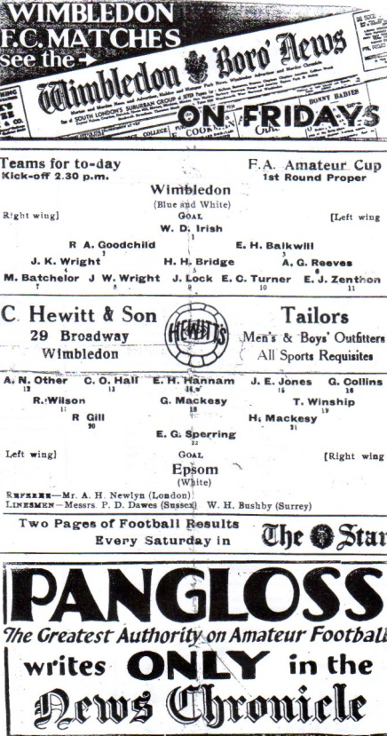
81 years ago today we defeated Tooting & Mitcham United 3-0 in the Amateur Cup. We would go on to reach the First Round Proper, where we lost 2-0 to eventual Finalists Wimbledon (see programme) but it was the last time we would ever reach this stage.

60 years ago this week we departed from the F.A. Cup at the hands of Margate with the press and some of the players squarely blaming our keeper Geoff Porter for the defeat. Porter had been heroic in earlier round wins against Dover and Dorking but what the press didn’t realise was that he had fallen awkwardly and chipped a bone in his thumb. He told the Manager Doug Whitehead and the Trainer Fred Aldred about it at half time but he was told to just get on with it! By the end of the game he could hardly hold a ball and was unable to prevent the 1-0 lead turning into a 3-1 loss.

Following the match, Geoff decided that it was time to do something different so he joined the Police Force instead and never played for the club again. He was able to help me enormously with this era of the club’s history while I wrote Two Legs Not Four in 2007 and he describes his decision as the best one he ever made! He came up to our F.A. Cup tie with Erith & Belvedere in August and at the age of 83 he still has the lump on his thumb where it was damaged!

20 years ago this week we defeated Clapton 2-1 in a League game. This was the first match I had missed, ironically since missing an away game at Clapton over thirteen years previously in April 1982 and broke my run of 697 consecutive Epsom matches.

Dorking Wanderers – History
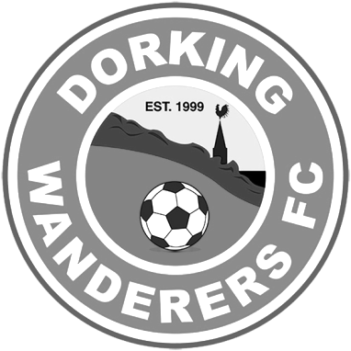
The Early Years – Five Promotions And A Ground Move!
Dorking Wanderers were founded as recently as 1999 and in a short space of time have begun to steadily climb the non-league pyramid from park football to the Sussex County League.

The founder members Marc White (the current chairman and manager), Peter Buckland, Mark Lewington, Ian Davidson, Lee Spickett and Penny Gregg brought the club to life and entered the fledgling team into the Crawley & District League for their inaugural season as the deadline had passed to join the West Sussex League. At this point the club was based at The Big Field in the village of Brockham.

After only one season the club transferred to the West Sussex League where in their first season (2000/01) the Division Four championship was secured. The reserves also won Division Five and ever since then the club has proudly run two teams.

This progress was maintained when Wanderers finished as runners-up in Division Three in 2001/02. The reserves were also in the honours and lifted the Dorking Charity Cup in 2002 – a feat they would repeat in 2004 and 2006.

Wanderers steady climb continued in the 2003/04 season when the club finished as champions of the West Sussex League Division Two. The reserves complimented this by winning Division Four, the Division Four Charity Cup, the Dorking Charity Cup and finishing as runners-up in the Tony Kopp Cup.

The journey through the West Sussex League was completed in 2005/06 when a third place finish was enough to elevate the team into the Premier Division. The reserves again were again not far behind and finished the 2004/05 season as champions of Division Three.

The most important season up to this time was in 2006/07 when Wanderers won the West Sussex League Premier Division title and with it earned promotion to the Sussex County League. The team managed solely by Marc White clinched the title with a 2-1 home victory on the final day of the season at West Humble. A fine achievement in only seven seasons. Wanderers also reached the fifth round of the Surrey Intermediate Cup where the team lost by the odd goal in seven to Epsom Eagles Seniors.

With promotion, a distinct possibility an enormous off the field effort enabled Wanderers to relocate during the season to the otherwise derelict venue of West Humble Playing Field in Dorking below the quaint setting of Box Hill. Wanderers were able to make West Humble home with the help of the club founder members, many of the playing staff and local volunteers not to mention kind local sponsors who provided the funds to make this a reality.

The Sussex County League Years - Senior Status Achieved
Wanderers made an immediate impact in the Sussex County League Division Three finishing in an impressive 4th place with the thumping of future champions Loxwood 4-1 at West Humble being the highlight. The club could have finished in a promotion spot, but could not maintain this level of performance against runners-up Bexhill United and Haywards Heath Town. West Humble, however, was not yet ready for the step up and so it did not affect the clubs fortunes.

The cups were where Wanderers shone brightest this year and for the first time the team reached the final of the Surrey Intermediate Cup where on the hottest day in May on record they faced Epsom Eagles Seniors. Unfortunately, the weather and a pre-match game of golf hindered the

team who lost 0-2.

The second season in Division Three again saw Wanderers challenge for a promotion spot and only a late collapse in form saw this ambition ended. The team again reached another cup final. This time it was the Division Three Cup where despite a stunning performance the team just could not score and went down 0-2 to Haywards Heath Town. Ironically, it was two future Wanderers Lois Freitas and Kevin Cooper who did the damage for Town that day!

The Surrey Intermediate Cup offered little consolation as the Wanderers’ nemesis Epsom Eagles Seniors ended their hopes for the third season running. Wanderers also reached the semi-final of the Mid Sussex Charity Cup.

Wanderers achievements were beginning to be recognised and five of the team were selected to play for the Sussex County League’s representative side against the Mid Sussex League and Kent League respectively. The players in who were honoured were alas Smith, Jones, Kevin Burgess. John McBride and John Tyler. Smith also achieved a rare feat and a Wanderers scoring record in a single game by hitting a double hat –trick in the 9-1 victory over Hurstpierpoint.

The 2009/10 season was one of development off the field. A slow start to the campaign meant the team had too much to do despite an impressive run of form either side of Christmas, but 4th place was still achieved. There was also to be no cup final as Wanderers lost 0-2 to Bosham at Wick in the Division Three Cup semi-final.

Despite this, the momentum was maintained at committee level and plans were made to develop the changing rooms, improve the hard standing areas for the supporters, catering and refreshment facilities.

All the hard work of everyone at Dorking Wanderers eventually was rewarded during the 2010/11 season as the team cruised to the Division Three championship finishing 16 points clear of second placed Hurstpierpoint and scoring 93 goals in the process. To crown a fantastic season Chris Williams finished as the division’s top scorer with 28 goals.

The season also heralded the introduction of Dave Smith as Hon. Club Secretary who in addition to stabilising the club’s core administration is also at the helm of looking after the club infrastructure. Dave has already introduced additional much needed Committee Members to the club in Frank Burgess and John who are now key members of the Team.

The early part of 2011 saw a great deal of work on the ground completed in order for promotion to be achieved including an entire home changing block being constructed whilst a physio room and a place to entertain visiting officials were added. The club also extended the concrete walkways and erected a fence to enclose the ground. The club are indebted to Jeremy Pain and Dave Smith who pioneered the whole project for the ground.

With Senior status now achieved Wanderers finished third in its debut season (2011/12) in Division Two and following an eventful summer were promoted to the top flight of the Sussex County League following an F.A. Appeal. Wanderers had other reasons to be happy as the club reached the Surrey Premier Cup final at the first attempt, whilst being knocked out of the Division Two Cup by Littlehampton Town at the semi-final stage.

In their first season Wanderers faced a real relegation battle, but were fortunate enough to survive. The club improved during the 2013/14 season and Marc White laid the foundations for the successful promotion campaign of 2014/15 which saw the club gain a place in Ryman League Division One South following a thrilling championship battle with eventual champions Littlehampton Town which went to the final day of the season, finishing in Second place but winning promotion to Step Four as Littlehampton hadn’t applied.

They currently compete in the Ryman League South Division, where they have made a great start.

Player Sponsorship
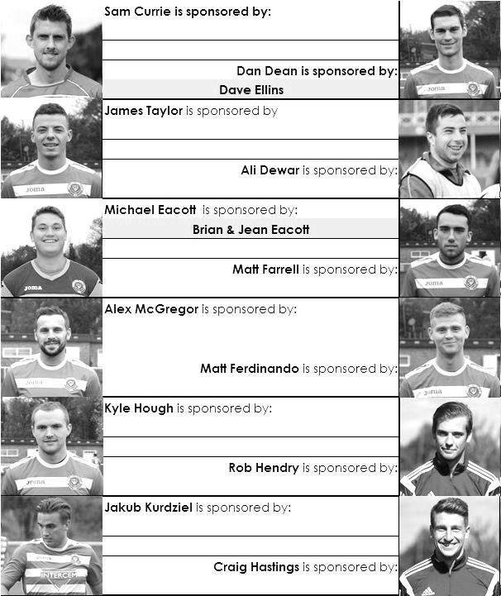

Here is the updated list for the 2015/16 season showing all of our players and Management that are currently available for sponsorship this season.

Sponsorship costs just £40 and it is easy to do. Just select a player who has not been previously sponsored and let a Committee Member know that you would like to sponsor them. Beware though. Until we have received the money it is possible for someone to jump in front of you, so don’t delay, sponsor today!

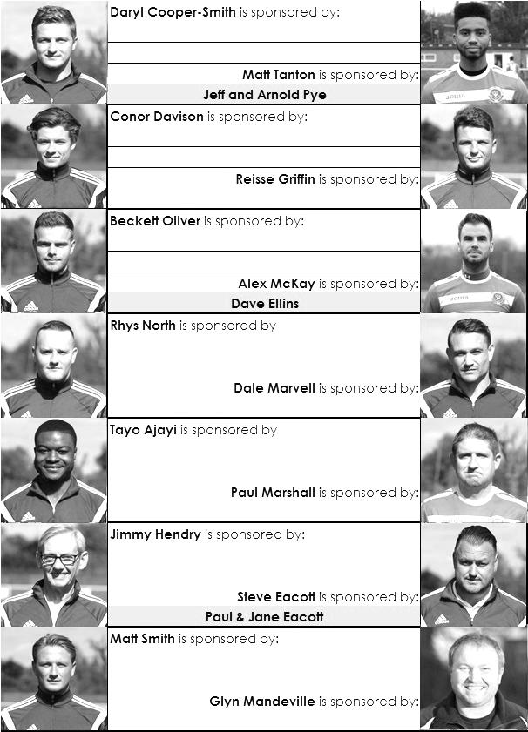

Centre page for results

Centre page for results



CCL Premier Division Club Directory
A.F.C. HAYES Telephone: 0208-845-0110 - Ground: Farm Park, Kingshill Avenue, Hayes, Middx. UB4 8DD - Colours: Blue and White Stripes/Blue/Blue

ASHFORD TOWN (Mx) Telephone: 01784-245908 - Ground: The Robert Parker Stadium, Short Lane, Stanwell, Middx. TW19 7BH - Colours: Tangerine & White Stripes/Black/Tangerine

BADSHOT LEA Telephone: 01252-320385 - Ground: Ash United FC, Shawfield Stadium, Youngs Drive, Shawfields Road, Ash, Hampshire. GU12 6RE - Colours: Claret/White/Claret

BEDFONT SPORTS Telephone: 0208-831-9067 - Ground: Bedfont Sports Club, Hatton Road, Bedfont, Middx TW14 8JA - Colours: Red & Black Hoops/Black/Red & Black Hoops

CAMBERLEY TOWN Telephone: 01276-65392 - Ground: Krooner Park, Wilton Road, Camberley, Surrey. GU15 2QW - Colours: Red & White Stripes/Blue/Red

CHERTSEY TOWN Telephone: 01932-561774 - Ground: Alwyns Lane, Chertsey, Surrey. KT16 9DW - Colours: Royal Blue & White Stripes/Royal Blue/Royal Blue

CHESSINGTON & HOOK UNITED Telephone: 01372-602263 - Ground: Chalky Lane, Chessington, Surrey. KT9 2NF - Colours: Blue/Blue/Blue

COLLIERS WOOD UNITED Telephone: 0208-942 8062 - Ground: Wibbandune Sports Ground, Robin Hood Way, Wimbledon. SW20 0AA - Colours: Blue & Black Stripes/Black/Black

COVE Telephone: 01252-543615 - Ground: Oak Farm Fields, 7 Squirrel Lane, Cove, Farnborough, Hampshire. GU14 8PB - Colours: Yellow/Black/Yellow

EPSOM & EWELL Telephone: 01737-553250 - Ground: Chipstead FC, High Road, Chipstead, Surrey. CR5 3SF - Colours: Royal Blue & White Hoops/Royal Blue/Royal Blue & White Hoops

FARNHAM TOWN Telephone: 01252-715305 Ground: Memorial Ground, Babbs Mead, West Street, Farnham, Surrey. GU9 7DY Colours: - Claret & Sky Blue /White/ Claret & Sky Blue

GUILDFORD CITY Telephone: 01483-443322 - Ground: The Spectrum, Parkway, Guildford, Surrey. GU1 1UP - Colours: Red & White Stripes/Black/Black

HANWORTH VILLA Telephone: 0208-831-9391 - Ground: Rectory Meadows, Park Road, off Hounslow Road, Hanworth, Middlesex. TW13 6PN - Colours: Red & White Stripes/Black/Black

HARTLEY WINTNEY Telephone: 01252-843586 - Ground: Memorial Playing Fields, Green Lane, Hartley Wintney, Hants RG27 8DL - Colours: Orange & Black/ Orange /Orange

HORLEY TOWN Telephone: 01293-822000 - Ground: The New Defence, Anderson Way, Court Lodge Road, Horley, Surrey. RH6 8SP - Colours: Claret & Sky Blue/Claret/Claret

KNAPHILL Telephone: 01483-475150 - Ground: Brookwood Country Park, Redding Way, Lower Guildford Road, Knaphill, Surrey. GU21 2AY - Colours: Red/Black/Red

SUTTON COMMON ROVERS Telephone: 01932-866386 - Ground: Sutton United FC, Gander Green Lane, Sutton, Surrey SM1 2EY - Colours: Yellow/Black/Black

RAYNES PARK VALE Telephone: 020-8540-8843 - Ground: Prince Georges Playing Field, Grand Drive, Raynes Park, London. SW20 9NB - Colours: Blue/Blue/Red

REDHILL Telephone: 01737-762129 - Ground: Kiln Brow, Three Arch Road, Redhill, Surrey RH1 5AG - Colours: Red and White Stripes/Black/Red

SPELTHORNE SPORTS Telephone: 01932-961055 - Ground: Spelthorne Sports Club, 296 Staines Road, Ashford Common, Ashford, Middx. TW15 1RY - Colours: Light & Dark Blue/Dark Blue/Light Blue

WESTFIELD Telephone: 01483-771106 - Ground: Woking Park, Kingfield Road, Woking, Surrey. GU22 9BA - Colours: Yellow/Black/Black

WINDSOR Telephone: 01753-860656 - Ground: Stag Meadow, St Leonards Road, Windsor, Berks SL4 3DR - Colours: Red/Red/Red

Surrey Senior Cup
Our successful Surrey Senior Cup winning team from 1981

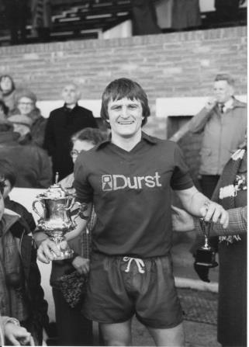
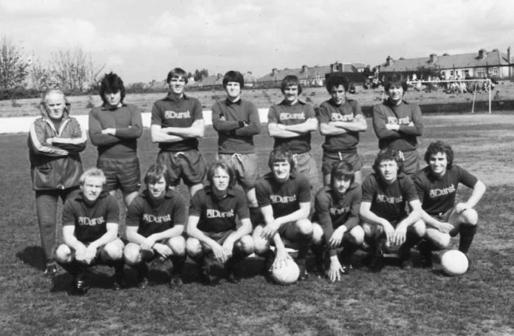
First Round
Ashford Town (Mx) | 27/10 | Beckenham Town
Camberley Town | 20/10 | Knaphill
Epsom & Ewell | 20/10 | Dorking Wanderers
Second Round
2 | V | 1
Chipstead | 3/11 | Chessington & Hook United
Colliers Wood United | V | Whyteleafe
Corinthian Casuals | V | Egham Town
Croydon | V | Farnham Town
Godalming Town | 10/11 | Guildford City
Horley Town | 1/12 | Badshot Lea
Leatherhead | V | Carshalton Athletic
Merstham | 1/12 | South Park
Met Police | 1/12 | 3
Molesey | 1/12 | Raynes Park Vale
Redhill | V | Tooting & Mitcham United
Sutton United | 30/11 | Walton & Hersham
Walton Casuals | V | Kingstonian
Westfield | 1/12 | Chertsey Town
Woking | V | Sutton Common Rovers

Surrey Senior Cup Review
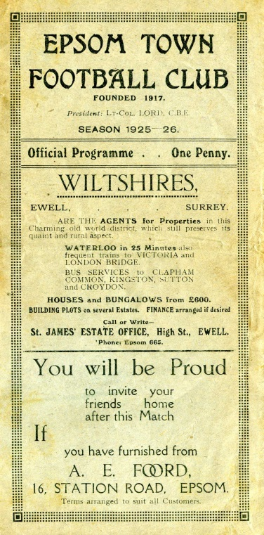
Tonight is our 204th Surrey Senior Cup tie. Over that period we have Won 98, Drawn 20 and Lost 84 with one match abandoned. Our goals in that time are F463 A394. It is also our 103rd home tie with 91 being played away from home and ten being at neutral venues.

Our very first Surrey Senior Cup tie was played at Krooner Park, when we defeated Camberley & Yorktown as they were then known by three goals to one on 18th October 1924. We trailed at half time, but two goals from Reg Marlow and the other from Tom Kirk saw us through. A win at Egham gave us a home tie with Weybridge in the first round, but we surprisingly lost this 2-1 at home to end our first County Cup run.

In 1925/26 we started our run with a 3-2 win over Godalming and took revenge on Weybridge by a goal to nil in the next round. This earned us a big match at home to Athenian League Summerstown, who were having a wretched season at the foot of the table, yet they were still two levels above us, and defeated us 4-2 at West Street. (see programme right) The following year was a marathon, as we played six matches but still went out in the first round. We required two replays to dispose of Carshalton Athletic, but minus flu victim Reg Marlow (who was in the middle of his run of five hat tricks in five consecutive matches) we crashed 3-8 at home to Woking.

Summerstown again ended the run 5-1 in the first round in their final season at the Earlsfield Road ground after two wins over Leyland Motors and Aquarius, the Water Board side from Honor Oak, but the 1928/29 season would prove to be the most memorable to date. It didn’t start auspiciously as we were held 0-0 at West Street by the Westminster Bank. We won the replay before knocking out Isthmian League giants Casuals 3-1 at West Street, but the best was yet to come as we humbled Wimbledon 4-1 at Kingstonian’s old Richmond Road ground in the Semi-Final.

The Final ended disappointingly, in front of 4,600 at Guildford City’s Josephs Road ground, we led Redhill at half time with a Bronk Challis goal, but three goals early in the second half changed the match, and a late Bob Earl consolation was not enough as the Lobsters won their first County Cup.

The 1929/30 season was the first time that the Town lost their opening match, away to Tooting Town by four goals to two, but the next season we went all the way to the Quarter-Finals again, by virtue of replay wins over Camberley & Yorktown and Egham. We then earned a trip to Dulwich Hamlet’s old Champion Hill ground, and I mean the first one, not the enormous one that only people over the age of 35 can remember, but the one before that, which was actually to the side of the new ground, behind the big terrace.

In front of 5,000 we dominated the game, despite only winning 3-2 (see programme left) but we would never win at Dulwich again. Mitcham Wanderers ended that year’s run 2-1 at West Street.

For the 1931/32 season the Blues were finally awarded an exemption to the First Round, or last 16, along with the big guns in the County. A Reg Marlow hat trick saw us past qualifiers Wills Sports by 6-2 before Kingstonian made their first visit to West Street since they were present at the opening of the ground, and eased to a 4-1 win in a match that was all over as a contest by half time with the visitors being three goals to the good.

In the thirties we were a very good side. However you wouldn’t have known this from our County Cup performances as we lost in the opening round for four years in a row to, Tooting & Mitcham, Dulwich again, Nunhead and in 1935/36 3-4 at home to Met Police.

So in 1936/37 it was back to the qualifiers, although Banstead Hospital knocked us out in extra time in the final qualifying round. This was a pity as we would have faced our tenants Ewell & Stoneleigh in the next round, but Banstead knocked them out too and actually went all the way to the Semi-Final.
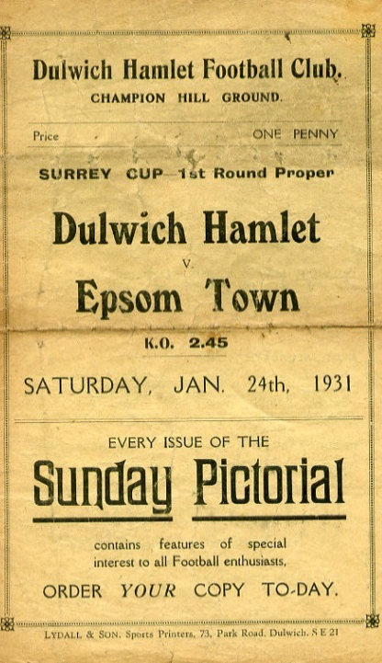
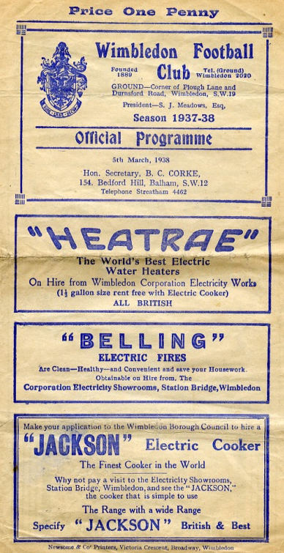
Despite going out in the qualifying rounds we received an exemption to the First Round again for 1937/38. We took full advantage, defeating Met Police 4-1 and Isthmian League Nunhead by five goals to one to reach the Semi-Final against the mighty Dulwich Hamlet. The match was played at the much-missed Plough Lane, Wimbledon see programme right), where goals from Rochester and Bruce ensured a replay at Richmond Road. There we were defeated 3-2 in extra time in a match where Jackie Pullen missed a sitter at the end of normal time with the score 1-1.

The press called it “a tragedy”, and despite Pullen netting in the extra period, we were unable to force another equaliser. It is worth noting that the Hamlet had won the previous year’s competition without conceding a goal, and were looking at repeating this achievement until they came up against us. (see programmes right and over page).

Tooting & Mitcham defeated us 3-2 at Sandy Lane in the opening round of the final pre-war competition During the war, the Cup was played for in 1939/40 by Epsom Town (losing in the Quarter Final to Nunhead), who continued through the war at West Street, before it was held in abeyance for a few years. It returned in 1943 with just nine teams entering, but Epsom Town reached the final, losing to

Tooting & Mitcham 3-1 at Sandy Lane in front of over 5,000 spectators (see programme below). However, the club would never win another match in the competition, losing over two legs to the Magpies again the next year, and to Vickers Armstrong after a replay in their final season of 1945/46.

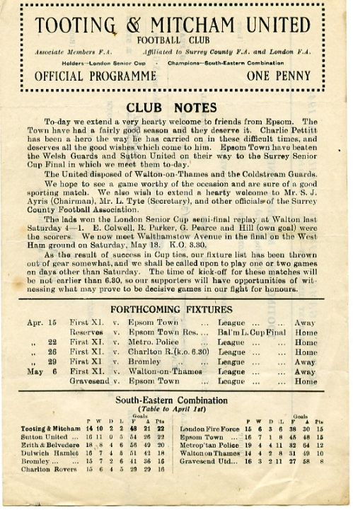
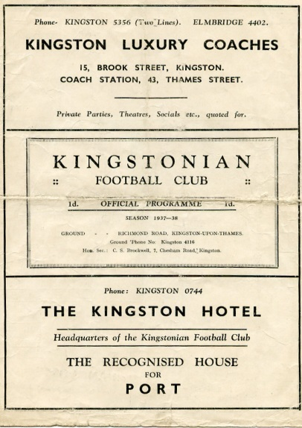
In that season Epsom F.C. defeated Carshalton Athletic 7-3 but were thrashed 6-0 in the Quarter-Final by the newly formed Corinthian Casuals at Richmond Road, where they ground shared with Kingstonian for a spell after the war. Despite reaching the last eight, we then had to play a qualifying round in 1946/47, but crashed out at home to Devas Institute. Oddly though we were back amongst the exempted clubs the following season, but it made no difference as we lost 3-2 at home to Corinthian Casuals again.

In 1948/49 we qualified past Devas (4-0) and Byfleet (6-1) but were defeated by the rising Walton & Hersham team 5-0 in front of 3,000 at Stompond Lane. The following season we were again exempt but Dulwich came away from West Street with a 6-0 win which put us back down amongst the qualifiers again!

It was a bit of a yo-yo really. We were obviously right on the edge of being one of the best eight clubs in the County, as we would rarely get beaten in the qualifiers.

McLaren Sports and Devas were beaten before we beat Hawkers, the Kingston based works side 6-1. Almost! We were nine minutes away from winning before were hit by a massive fog that was so heavy it caused our home Reserve team game to be called off at exactly the same time ten miles away in Epsom, with us leading 4-0 at the time. It was an unfortunate day! We played the following week and edged through 4-3 before again being hammered by Corinthian Casuals, this time 7-1 at West Street.

We were facing a regular scenario. Beat a few average teams before coming up against either Casuals or the Hamlet. For the next three years it would be the latter, winning 4-2 and 4-3 at West Street in consecutive seasons. However, the 1953/54 season would see the tables turned for a change.

Firstly, we received another exemption, for reaching the Quarter-Final the year before, and the draw was kind. We defeated Addlestone and Malden Town without conceding, and faced our nemesis in the Semi-Final at Plough Lane, where a Roy Dymott goal was enough to secure a draw

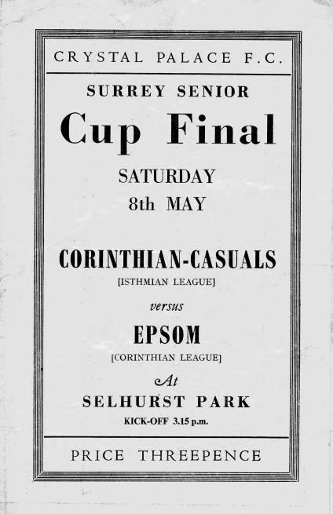
there, just as we had 16 seasons before. This time the replay was at Sandy Lane, where 7,000 witnessed a stunning comeback. We trailed 2-0 with eighteen minutes left, but Gordon Hurst pulled a goal back, and then right on full time as the crowds were beginning to drift away Bill Wiles equalised, with Bobby Avis securing the win with a goal in the second period of extra time. (see programmes above) However, our reward for defeating Dulwich was a Final against Corinthian Casuals! The game was played at Selhurst Park in front of 6,159 and was a let down with our boys conceding once in each half, despite being the better side on the day. (see programme left)

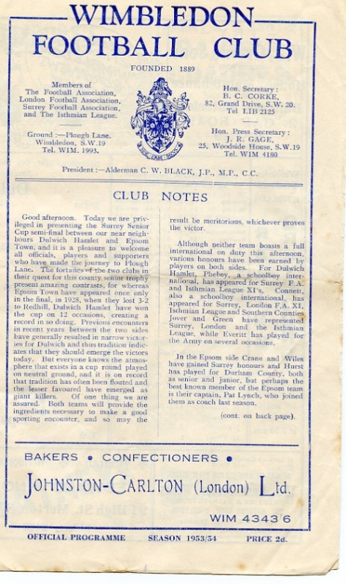
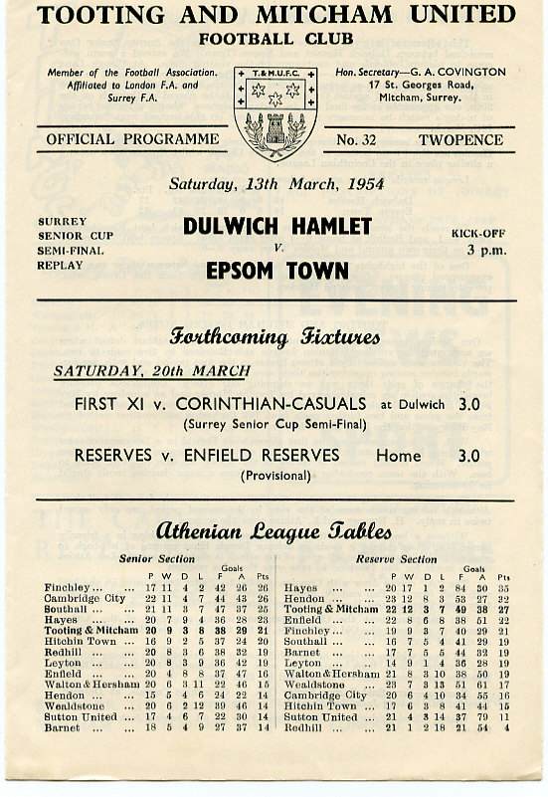
It was Dulwich again in 1954/55 that knocked us out 4-1 and although we edged past Banstead 3-2 on our first visit to Merland Rise, Tooting & Mitcham put us out in 1955/56. The next season was one of our best though, as we battered Kingstonian 5-1 at West Street before then smashing Dulwich Hamlet up 5-3. However, the semi-final brought an unlucky 2-1 defeat to Wimbledon at Sandy Lane.

It seems downright bizarre that we always seemed to

play the same teams, yet never met Sutton United in this competition until 1957, when Johnny Bangs and Jan Sorensen were the scorers in a 2-0 win at West Street. (see programme right). It would be twenty-four years before we would meet again.

In the meantime our luck was about to change for the worse. Woking defeated us 4-2, and then we crashed 5-1 at Dorking in December 1958. This result sent us back to the qualifiers, where we would remain until 1981. As our fortunes plummeted, we only reached the First Round once in the sixties, when wins over Whyteleafe, Chobham (after a replay, awarded because the pitch there was undersized) and Camberley gave us a home tie against, yes, Dulwich again! The attendance of 608 was the best we’d get until the Vase run of 1975 as the visitors won 2-1.

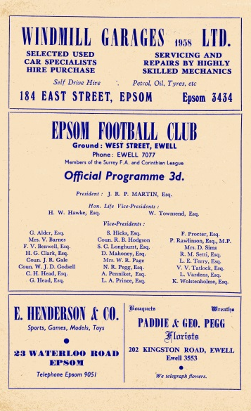
And it was 1975 when we next reached that stage of the competition, slipping up 3-4 at Addlestone, although at 4-0 down we gave them a fright and this helped when we met and defeated them later that season in the F.A.Vase Quarter-Final.

In 1976/77 we reached the First round again, losing 2-1 at home to Walton & Hersham after a replay. This earned us an exemption to the final qualifying round, ahead of many lower league sides, but not quite up with the big boys yet. Tooting & Mitcham and Egham defeated us in the first round in the next two seasons, with Dorking knocking us out in the qualifiers the next year.

In 1980/81 we had a good side, but no one would have expected what happened next. We opened up with a narrow 2-1 win over Westfield before winning 6-0 at Ash United in the First Round. The Quarter-Final drew us at Walton & Hersham and we got a 1-1 draw there, finishing them off in the replay 4-2. Enter Sutton United, who were having a very good season themselves which would end at Wembley for an F.A.Trophy Final. We held our more illustrious opponents goalless before winning the replay at West Street 3-2. After beating Sutton, Woking held no fears for us, as they were bottom of the Isthmian Premier Division, and we defeated them 2-1 at Sandy Lane to win the cup for the first, and so far only time in our history. (see programme left)

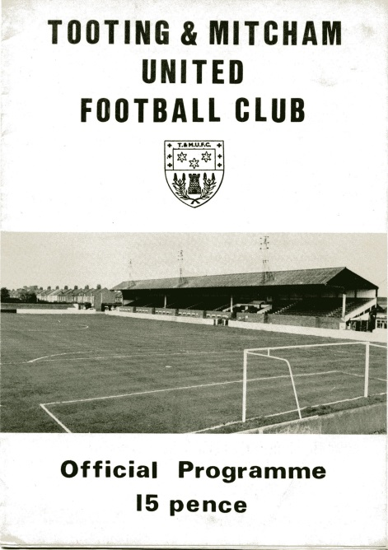
As holders, this had the added benefit of giving us a full exemption again, but despite defeating Tooting & Mitcham and Walton & Hersham, we were robbed on a technicality against Croydon.

Pat O’Connell had left the club, taking much of the team with him and Adrian Hill had limited time to get players in. In addition the Surrey F.A. rules stated that a player had to be registered for 28 days before playing in this tie, so we had all sorts of troubles even fielding a side. Leading striker Steve Hill even played in goal for us, despite having a stress fracture in his shin that prevented him taking an outfield role, and Croydon won 4-0, ending our brief hold on the trophy in criminally farcical circumstances.

In January 1983 Sutton defeated us in the County Cup for the first time ever with a 2-1 win at Gander Green Lane, and the following season the two teams met in the Final, after we had defeated Addlestone & Weybridge (after a replay), Banstead and Croydon, again after a replay. However, we were blown away, losing 4-0.

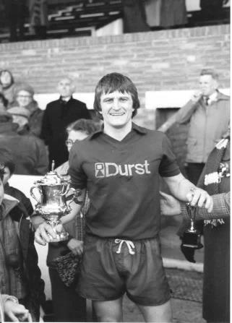
And they did it again the following season with a 4-1 win at West Street after we had held them goalless just two days previously at Sutton. There was a temporary respite in 1985/86 when it was Kingstonian that knocked us out 2-0 at Richmond Road, but it was Sutton again in the Semi-Final of 1986/87 by five clear goals.

We reached the Semi-Final again in 1988/89 but despite holding Carshalton Athletic 2-2 at home, we were harshly defeated 3-0 at Colston Avenue, and three narrow quarter-final defeats in three years followed to Woking, Whyteleafe and Carshalton again.

Since then we have achieved very little in the competition with exception of a Quarter-Final appearance in 2001/02 when we were defeated 3-1 by a Wayne Routledge inspired Crystal Palace, and in 2008/09 when we reached the Semi-Final, aided by an historic and fantastic 3-2 win at Sutton United, plus wins over Redhill and Corinthian Casuals. This gave us the opportunity to visit Step Three side at the time Ashford Town (Middx), but they were too strong for a tired Epsom team and eased through 4-1, despite Robbie Burns equalising to make it interesting for a while.

The competition’s recent reorganisation means that there are no exemptions any more, which makes for a more open draw, and maybe as a result of these potential extra matches, some of the bigger sides have played weaker teams in recent years. This of course does open the way for smaller teams to progress in the competition and recently we have seen Merstham, Ashford Town (Middx) and Godalming Town winning the trophy. Who knows, maybe these days it isn’t as impossible to repeat our 1981 win as you might think!

Left: Our Captain Peter Gaydon lifts the Surrey Senior Cup at Sandy Lane on Easter Monday 1981.

Match and Ball Sponsorships – 2015/16
Opponent | Date | Match and Match Ball Sponsor
Hoddesdon Town | 18/07/15 | Geoff Dyke
Windsor | 08/08/15 | Club President Stella Lamont
Erith & Belvedere (FAC) | 16/08/15 | Mike Lovett
Raynes Park Vale | 31/08/15 | EEFC Management Committee
Colliers Wood United | 08/09/15 | Bookham Building Shop – www.buildingshop.co.uk
AFC Hayes | 19/09/15 | John Bonner
Farnham Town | 26/09/15 | Ezara and Inaya Beddoe – our youngest supporters!
Chertsey Town | 17/10/15 | Club Media Officer – Richard Lambert
Dorking Wanderers (SSC) | 20/10/15 | Tony Ferdinando
Chessington & Hook United | 07/11/15
Hanworth Villa | 21/11/15
Guildford City | 05/12/15
Cove | 08/12/15
Sutton Common Rovers | 19/12/15
Redhill | 02/01/16
Spelthorne Sports | 16/01/16
Hartley Wintney | 30/01/16
Bedfont Sports | 13/02/16
Horley Town | 27/02/16
Knaphill | 12/03/16
Westfield | 26/03/16
Badshot Lea | 09/04/16
Camberley Town | 16/04/16
Ashford Town (Mx) | 30/04/16
Ashford Town (Mx) (LC) | tba
For League, League Cup and Surrey Senior Cup Matches:
Match sponsorship - £40.00 Match ball sponsorship - £25.00. Combined £55.00.
For F.A. Cup and F.A. Vase matches:
Match sponsorship - £50.00 Match ball sponsorship - £30.00. Combined £65.00.

Sponsorship includes: (x2 for match, x3 for match and ball)

Admission, programmes, hospitality and advertising and mascot for the day (if required).
If you are interested, just speak to a Committee Member, or drop me an email at: richard.c.lambert@gmail.com


We also thank our Kit Sponsors INTERCEM

Salts Super Six Predictor
The Salts Super Six Predictor Competition is live again and the tickets are on sale at today’s game to the left of the gate. Six Championship fixtures are on the list this evening.

The competition is easy to play! To win, you simply need to predict the results of the six matches correctly from the three options, fill in the form and make sure it is back with our sellers before the deadline on the ticket.

If you are a club regular, you just need to place your name on the sheet, although if you aren’t, then we’ll need a contact number from you too. We will announce any winners on the website within three working days, so don’t worry we won’t miss you!

The jackpot keeps rising and is already up to £284 How much higher will it go?

Please note that if there is more than one winner, the prize pot would be shared between the winners. All you need to do now is have a go, as many times as you like!

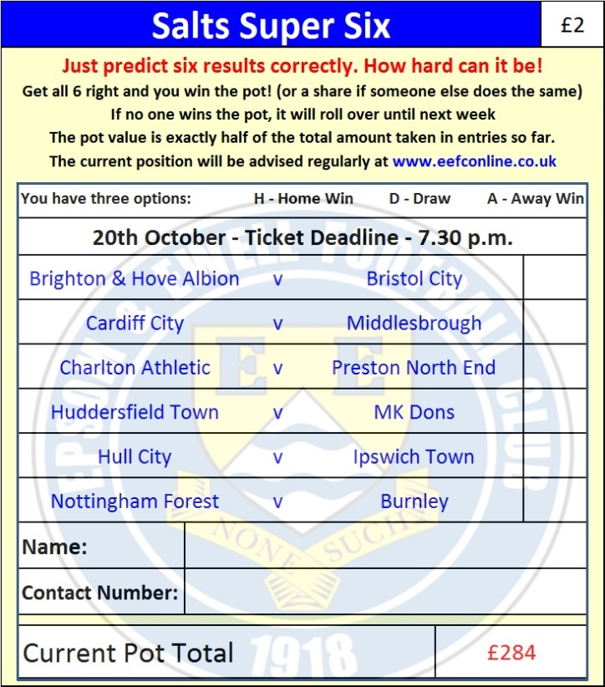
Good luck!

Surrey Senior Cup – First Round
Tuesday, 20th October 2015 - Kick-off 7.45 p.m.
Epsom and Ewell  (Royal Blue & White hoops) | V |  | Dorking Wanderers  (All Yellow)
Squad | NUMBERS
Michael Eacott |  |  | Gary Ross
© Sam Currie |  |  | Slavomir Huk
Matt Tanton |  |  | Jake Hill
Dale Marvell |  |  | Ben Dyett
James Taylor |  |  | Luke Hackett
Dan Dean |  |  | Chris Boulter ©
Matt Farrell |  |  | Jordan Willis
Alex McKay |  |  | Tom Familton
Kyle Hough |  |  | Alex Rose
Daryl Cooper-Smith |  |  | Harry Shipton
Rob Hendry |  |  | Elliott Thompson
Reisse Griffin |  |  | Jerome Beckles
Conor Davison |  |  | Darryl Coleman
David Neill |  |  | James Duff
Rhys North |  |  | Tom Davis
Tayo Ajayi |  |  | Anthony Oaks
Matt Ferdinando |  |  | Sean Findlay
Craig Hastings |  |  | Tom Tolfrey
Beckett Oliver |  |  | Phil Page
Alex McGregor |  |  | Kev Terry
Jakub Kurdziel |  |  | George Cousins
Glyn Mandeville | MANAGER |  | Marc White
Matt Smith | ASSISTANT |  | Lee Spickett
Steve Eacott / Alex McKay / Jimmy Hendry | COACHES / PHYSIO |  | Tom Duke / Dean Milton /  Grant Steele / James Shaw
REFEREE: D.Bandara (Leatherhead)
ASSISTANTS: M.Ford (Sutton), M.Westlake (Sutton)
Today’s Match and Match Ball are sponsored by
Tony Ferdinando – father of our skilful right winger, Matt

OUR NEXT VISITORS TO HIGH ROAD
Chessington & Hook
Saturday 7th November 2015 - Kick-off 3.00 p.m.
Combined Counties League – Premier Division

